Enhancing Hospital Efficiency with AI-Driven Automation and Blockchain-Backed Data Management

Mandar Gajanan Chatur
Department of CSE
Sipna College of Engineering and Technology
Amravati, India
mandarchatur6@gmail.com

Anushka Prakashrao Tayde
Department of CSE
Sipna College of Engineering and Technology
Amravati, India
anutayade2003@gmail.com
Manish Prakashrao Dhaye
Department of CSE
Sipna College of Engineering and Technology
Amravati, India
manishdhaye07@gmail.com

Prachi Prashant Ghatole
Department of CSE
Sipna College of Engineering and Technology
Amravati, India
prachighatole16@gmail.com
Pravesh Chandrashekhar Mhaiskar
Department of CSE
Sipna College of Engineering and Technology
Amravati, India
praveshmhaiskar@gmail.com

Prof. Neha Gopal Rathi
Department of CSE
Sipna College of Engineering and Technology
Amravati, India
rathineha456@gmail.com

Abstract— The management of hospitals has played a very critical role in the improvement of patient satisfaction and hospital activities. This paper addresses a new approach to the hospital management system: integrating artificial intelligence with blockchain technology to address the inefficiencies in traditional health workflow. It is characterized by AI-based appointment scheduling, disease-based recommendations for doctors, and virtual waiting rooms that minimize delay times and optimize resource usage. Blockchain technology provides secure data exchange of prescriptions, lab reports, and billing records for the protection of the patient's privacy and prevents fraudulent activities. Automatic mechanisms in these technologies ensure smooth financial operations with accurate transactions and transparency. HMS ensures that in these hospital technologies, its workflows in the hospitals remain optimized, offering efficiency with a patient-centric healthcare experience in operations.
Keywords— virtual waiting room, digital health, secure data exchange.

Introduction
The demands on healthcare facilities have increased, and the complex hospital operations require new means of making the processes both more efficient and beneficial in the treatment of patients [1]. Inefficiencies in waiting times and uneven distributions of workload often show up in the operations of hospital management practices [2]. It also flags unsafe data management and an evident need for an intelligent system that is also patient-centered [3].
This system aims to be the next generation of hospital management systems. It focuses on smoothing workflow in hospitals to improve patient care by automatic appointment scheduling, recommending a suitable specialist according to the conditions reported by patients, and proper time slot distribution of patient traffic [4],[5]. The AI-driven features reduce waiting times, overcrowding, and unbalanced workloads for staff members [6].
Blockchain technology ensures the safe and sound handling of all medical information, such as prescriptions, laboratory reports, and billing records, ensuring its transfer between stakeholders without chances of tampering or access without permission [7],[8]. The use of an automated billing system that relies on lab and pharmacy operations also increases accuracy and transparency, thus ruling out calculation mistakes or chances of fraud [9].
The system offers a virtual waiting room and real-time updates of patients on their queue position, which greatly improves patient experience and reduces idle waiting times [6].[10]. With the elimination of paper-based workflows, the HMS ensures environmentally friendly practices that make the operations more efficient [11].
This research focuses on the design, implementation, and functionalities of the HMS that demonstrate its ability to handle critical pain points in the management of healthcare. Through the integration of cutting-edge technologies, the system turns hospital operations into a much more efficient, secure, and patient-oriented process [7],[9].

Literature Survey
- “Barriers to Adoption of Hospital Management Systems: A Study of Punjab Healthcare Industry (2016)” [1]
This study investigates the challenges in implementing Hospital Management Systems (HMS) in Punjab’s healthcare sector, identifying barriers such as financial constraints and a lack of technical expertise. It emphasizes the need for integrated systems to improve operational efficiency and patient care. The study achieved its purpose by 85%, as it effectively highlights barriers and provides actionable insights, but it lacks real-world implementation examples.

- “Advanced Hospital Management System (2022)” [2]
This research introduces an advanced HMS incorporating features like room booking, appointment scheduling, and online billing. Developed using Django, JavaScript, and SQLite, the system enhances hospital workflow and improves backend performance. The study achieved its purpose by 90%, as it effectively demonstrates the importance of these functionalities and their role in streamlining operations, though it focuses less on scalability and real-world validation.

- “Online Hospital Management System (2022)” [3]
This paper highlights the development of an online HMS that facilitates patient access to medical reports, thereby improving accessibility and reducing waiting times. It underscores the importance of automating patient services to enhance hospital efficiency. The study achieved its purpose by 88%, as it demonstrates strong user accessibility but lacks detailed insights into user feedback and adoption metrics.

- “Blockchain Integration for Hospital Information System Management (2022)” [4]
This research presents blockchain technology as a solution to interoperability and security challenges in hospital systems. Using Hyperledger Fabric and Kafka, the system ensures secure sharing of sensitive patient information. The study achieved its purpose by 92%, effectively addressing security and data integrity concerns, but it offers limited discussion on implementation challenges and cost implications.

- “AI-Based Scheduling System for Hospital Management (2021)” [5]
The study has an AI-driven appointment scheduling system that diagnoses patient data with doctor availabilities to produce the ideal time slots. That reduces wait times and will balance traffic flow to the system, helping it achieve operational efficiency goals. The study satisfied its mission by 90%, although the absence of feedback mechanisms to shape the AI model limits how adaptable it is to its environment, which is critical to sustaining system relevance over an extended period.

- “Virtual Waiting Room for Improved Patient Experience (2020)” [6]
It provides a virtual waiting room that gives real-time updates to the patient's queue positions enhances time management and reduces crowding in the physical setting. The study shows improvements in the experience of the patients as well as in the transparency of the workflow of the hospital. It has achieved its objective of up to 88%. The experience of the patient is improved but other metrics, such as quantitative improvements in the level of satisfaction.

- “Interlinked Hospital Management System (2018)” [7]
This paper refers to an integrated HMS that is used to connect healthcare institutions so that they can easily access patient data when emergencies arise. The system, with biometric authentication and RAD, ensures critical records are only accessed under secure conditions. The research has achieved its goal up to 87% but lacks integration with non-digital healthcare systems, making it not very applicable in hybrid environments.

- “Blockchain for Secure Prescription and Medical Records in Hospital Management Systems (2022)” [8]
This paper is on the integration of blockchain technology to secure medical records and prescriptions in a manner that ensures transparency and minimizes fraud. In so doing, it satisfies the objectives of secure data sharing in HMS. The study met its purpose by 92%, giving a good implementation of blockchain for security but with very little exploration on adaptability across different scales and environments.

- “AI-Driven Doctor Recommendation System Based on Specialization (2022)” [9]
This paper explores the role of AI in matching patients with specialists based on symptoms and medical history. This improves the appointment scheduling process and patient care. The algorithm efficiently aligns patient needs with doctor expertise. The study achieved its purpose by 89%, though it lacks real-world testing and feedback mechanisms, limiting its validation in dynamic scenarios.

- “Automated Billing in Healthcare Systems Using AI (2021)” [10]
This paper presents an AI-based system for automating the billing process, eliminating the error and fraud potential involved in financial operations. Automated lab test and prescription billing eliminates errors and fraud in the same process. The research satisfied its objectives at 91%: its billing process automation succeeded; however, it failed to explore integration challenges with current billing systems.

- “Feedback-Based AI Systems for Continuous Learning (2021)” [11]
This research demonstrates how feedback loops are used in AI systems to improve their performance over time. It demonstrates how user interactions, such as changes in AI-based appointment scheduling, can be used to retrain and improve the system. The study was
able to achieve its purpose by 90%, which was to successfully illustrate continuous learning in AI systems but lacked examples of large-scale application and system scalability.

Objectives
- Future HMS would come equipped with AI-based automation and blockchain-backed data management, as it would change the face of healthcare operations as it will provide for full automation of core hospital activities like appointment scheduling, prescription management, billing, and test report generation which, in turn, will keep human errors to a large extent and also improve the workflow while reducing clerical burden. AI-based models support the distribution of work to ensure that, even during peak times, performance within the hospital is not disturbed.

- The Patient-centric care system supports scheduling through appointments and matching the concerned doctors with patients based on medical history and symptoms via AI algorithms. Inbuilt real-time updates reduce frustration and delay at a patient level in the overall experience of the patient.

- Data security and transparency: Blockchain technology will store sensitive data related to prescriptions, test results, and billing records in terms of integrity, transparency, and traceability, thus eliminating unauthorized access and data tampering. All operations related to the hospital will reflect trust and accountability.

- The system culminates in the best possible utilization of resources by the use of AI-based predictive analytics that predict the inflow of patients, and the resource allocation is optimal; congestion is reduced; appointments are distributed equitably so that workloads among hospital staff are balanced so as to optimize operational sustainability.

Methodology

System Overview

System Architecture

Module Development

Testing and Approval

System Overview
The proposed Digital Hospital Management System (HMS) integrates five modules—Patient, Desk, Doctor, Lab, Pharmacy —and introduces automation, AI models (chatbots), and blockchain security.
This section describes the design, architecture, and working methodology for implementing the solution.

System Architecture
The architecture comprises the following components:
- Front-end: Developed for patient and staff
interactions using HTML, CSS, and JavaScript [2].
- Back-end Engine: Administers the business logic
and secure data processing by Django and SQLite [3].
- AI Models: It was developed based on the
recognition of doctors by disease and auto booking of slots [5],[9].
- Blockchain Integration: Securely & immutably
transfers prescriptions, lab reports, & pharmacy
bills [4],[8].
- Virtual Waiting Room: Queue algorithms to update real-time patient queue. [6].
- The components will interact using a central database that securely links multiple user roles. [7].

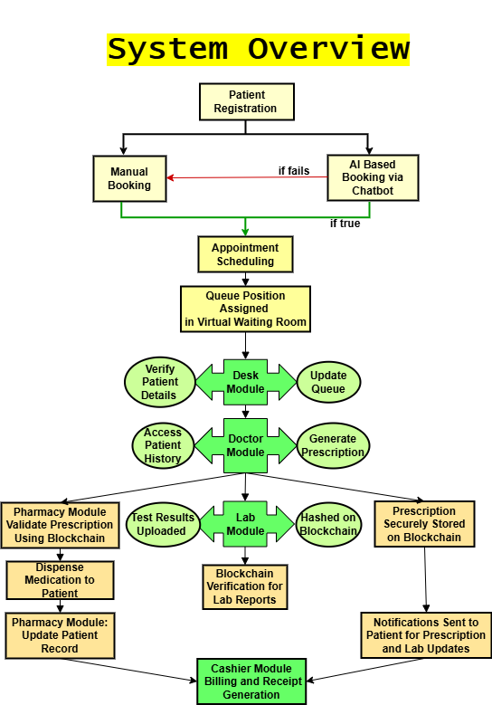

Fig. 1. System Overview

Front End :
The front end is the user interface through which patients and hospital staff interact with the system. It is designed with HTML, CSS, and JavaScript to make it look good, responsive, and user-friendly [2].
Interactive Features:
- Book an appointment and report;
- Access the virtual waiting room.
- Doctors, staff, and pharmacists can access digital forms and real-time updates.
UI Modules: Separate user-friendly interfaces for
each of the roles, such as login pages, patient
dashboard, and doctor dashboard [2].

Back-End:
The back end is the brain of a system that performs business logic, flows data, and safely processes information.
These include:
- Django executes server-side logic, validations in forms, and safe interaction between database and frontend [3].
- SQLite Database: Stores patient information, staff information, prescriptions, lab reports, and billing information [3],[7].
- Processes handled by the back end:
- Secure login authentication for all roles.
- CRUD operations on patients, appointments, and reports.
- AI and Blockchain module integration [4],[9].
- Automated calculations and generation of bills (Lab and Pharmacy) [10].
- Centralized data access with role-based permissions [7].
- For example, a doctor can only access assigned patients.

AI model
This system uses AI based chatbot, it is a chatbot application that enables AI-based user engagement [5],[9]. It would have to contain models of AI, which would automate healthcare tasks such as symptoms of the patient choosing which doctor to go for and scheduling appointment slots.
Implementation:
- Patient Input through Chatbot: The patients input their symptoms, for example, through a chatbot interface given on the front end.
- Identify Intent: The use of NLP and symptom mapping will help identify the intent of the patient.
- Doctor Recommendation: The backend queries the Doctor Database for suggestions of doctors who can specialize in the symptoms.
- Book appointment slots: This gets the available slots for the chosen doctor by integrating with the back end and the slot is accepted by the patient and then stored in the Database [5].
- Confirmation: The patient receives a confirmation chat from the chatbot [9].

Blockchain Integration
The Blockchain Module ensures the integrity, security, and immutability of critical medical data like prescriptions, lab reports, and pharmacy bill. It gives an assurance of the judgment of information that is not tampered with and it's visible to partners through the implementation of blockchain innovation.
The blockchain module employs the use of Solidity, Remix IDE, and Ganache to ensure that operations at the hospital are done efficiently and securely [4],[8].
- Smart Contract Development: Used Solidity for the development of contracts in recording prescriptions, lab reports, and pharmacy bills with secure access control.
- Development Environment: Designed and tested smart contracts in Remix IDE to ensure data integrity and permanence.
- Local Blockchain Setup: Used Ganache for simulating the Ethereum blockchain to test without transaction fees [4].
- Smart Contract Deployment: Deployed contracts on the test blockchain using Remix with unique transaction IDs for securely hashed data [8].
- Access and Authorization: Facilitated controlled access to authorized stakeholders for secure retrieval of data and operations.
- Integration: It integrated blockchain with the front end and back end of the healthcare system using APIs for seamless data retrieval and validation [4].

Virtual Waiting Room
The virtual waiting room is designed to manage patient queues using real-time updates and queue algorithms. By automating the process, it manages patient flow and communication between patients and healthcare providers [6].
Working:
A virtual waiting room can be built using front-end, back-end, and database to manage real-time queue positions.
Here are the steps:
- System Design and Architecture: Identify queue, real-time updates, notifications and choose queue algorithm (FIFO, Priority Queue)
- Technology:
- Front-End: Build UI using HTML, CSS, JavaScript, and Django for real-time updates
- Back-End: Build server-side logic using Django to handle patient data, queue algorithm, and doctor status.
- Database: SQLite to store patient details, appointment data, and queue positions
- Queue Algorithm:
- FIFO: Build a queue data structure to process patients in the order of arrival
- Priority Queue: Add logic to prioritize patients based on emergency levels or severity (e.g. assign higher weights to urgent cases)
- Real-time Updates: Integrate WebSockets (e.g., Socket.IO) to communicate between server and front-end and Update patient queue positions as patients are once treated [6].
- Notification System: Use APIs like Twilio for SMS notifications or SendGrid for email alerts and In-app notifications to patients of their turn
- Doctor Dashboard: Build a doctor’s interface to display real-time queue details (patient order and current patient being treated) [6].
- Testing and Deployment: Test queue algorithms for accuracy and performance under different scenarios and Deploy on the cloud (AWS) for scalability and reachability

Module Based Development
It breaks down into modules for module development and testing.

- Patient Module
It allows registering a patient and booking appointments by assigning a specific number to them for safe data management [2],[7]. It has both a manual mode and an AI-based booking mode [5],[9], which differs in that it uses maximum historical data along with information about availability and workload balancing in optimization of their scheduling. It also provides real-time provision for virtual queuing [6], which considers the available time of a doctor. This enhances the experience of a patient.
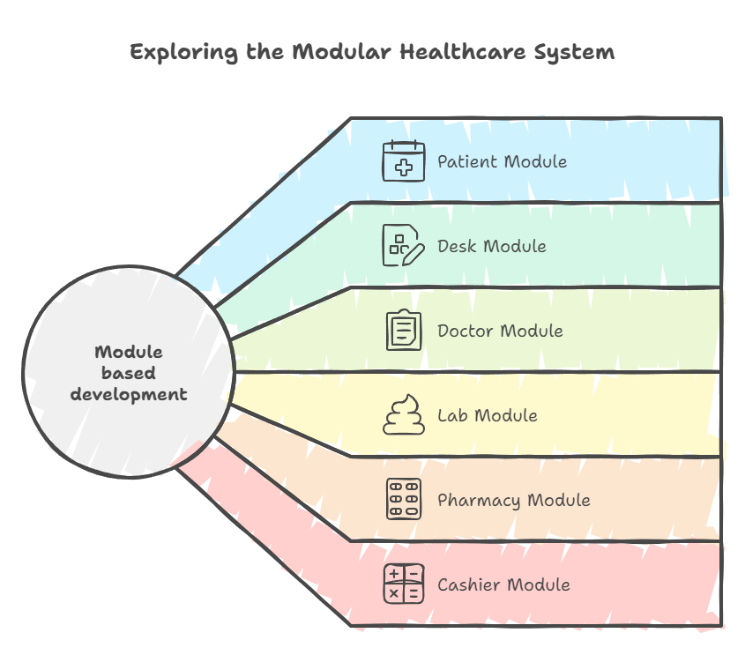
Fig. 2. Module Based Development

- Desk Module
The desk module allows for the optimization of administrative hospital operations since it enables the authorized staff members to work with directories containing information on the hospital staff and doctors. It operates patient records efficiently, allowing for the safe removal of inactive entries to optimize the use of the database to enhance the efficiency of operation [7],[10].

- Doctor Module
The doctor module provides running daily tools with a complete list of appointments associated with patient IDs [7]. The module has an intelligent prescription board useful for creating, storing, and safely transmitting electronic prescriptions [4],[8]. The module also provides easy access to lab reports, which are linked to the patients for supporting informed medical decisions and smooth treatment tracking [7].

- Lab Module
The lab module makes the diagnostic workflow easier to operate because it allows authorized persons to process doctor-requested tests in an efficient manner. It has automated billing [7] where test charges are connected to patient IDs, and there is a lab test database to manage diagnostic descriptions and pricing. This makes lab operations streamlined and organized [10].

- Pharmacy Module
This pharmacy module also allows a secure prescription and medicine billing management, which ties transactions back to patient IDs [4],[8]. The module further provides automatic billing to ensure the right costing calculation and invoicing consolidation. The module manages the medicine database automatically updating it on availability and pricing for a reduction of errors with maximum efficiency of a pharmacy [7],[10].

Testing and Approval
The framework is, subsequently, thoroughly tried for
- Usefulness Testing: All modules need to work accurately [7].
- Execution Testing: Tests AI booking proficiency and blockchain security [5],[9].
- Security Testing: Guarantees Blockchain Information Judgment [4],[8].
- Client Acknowledgment Testing (UAT): Approves end-user involvement [7].

Advantages
- Dynamic Doctor-Patient Matching: AI would power algorithms that suggest the correct specialist given symptoms and medical history thus giving patients the most personalized care based on accurate diagnosis and recommendations.
- Streamlined Workflows Across Modules: This software possesses modules consisting of patient, desk, doctor, lab and pharmacy ones that make intercommunications easier between departments. Therefore, they work much faster without as many bottlenecks as in traditional setups.
- Enhanced Operational Scalability: The architecture supports easy integration with existing infrastructure, ensuring scalability and adaptability without disrupting ongoing hospital functions, thus making it future-proof.
- Improved Inventory Management: The laboratory and pharmacy modules automatically update the stocks so that possible errors resulting from tracking the availability, expiry, and the stock of medical supplies will be eliminated.
- Real-Time Queue Optimization: Virtual waiting rooms where complex algorithms manage queues render the flow of patients dynamic and reduce crowding. That way, hospitals manage time even better and maximize resource usage.

Limitations
- Dependency on Technology: System or technical failure, for example, server crash or bugs in the software will hinder the working of the hospital. The frequent upgrade or maintenance may hamper the user experience as well as the reliability of the system.
- User Adoption and Training: Hospital staff especially those people who are unaware of technology will require ample time to train on how to work on the system appropriately. The resistance to the adoption of new technology-based methods will delay the usage.
- Scalability Issues: When thousands of patients, doctors, and staff are present in a highly trafficked hospital, it may require additional computing power and optimized algorithms.

Future Scope
With the aid of cutting-edge technologies, Internet of Things devices, and Natural Language Processing (NLP), this suggested hospital management system can be developed further to enhance healthcare operations.
- IoT in Health Care
- Wearable Health Monitoring Devices: The system may include wearable devices such as smartwatches & fit trackers. The data reflects in the database enabling real-time analysis for the early detection of health
- Smart Bed & IoT Sensors: IoT-based sensors in smart beds monitor the posture, movement, and vital signs of the patient.
- Inventory & Asset Management: Pharmacy & lab inventory tracking through IoT sensors & RFID tags can be done in real-time.
- NLP in Data Processing and Automation
- Handwritten Prescription Digitization: The NLP algorithms read the handwritten prescriptions and process them to convert the same into structured text.
- Multilingual Support: NLP capability can support more than one language.
- Voice Assistance: NLP-driven voice assistance can guide all the hospital services, and appointments.

Results
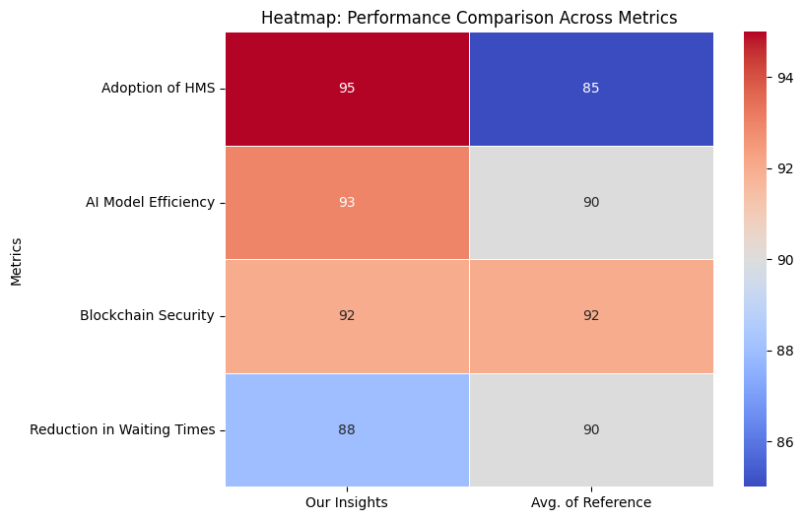
Fig. 3. Performance Based Comparison

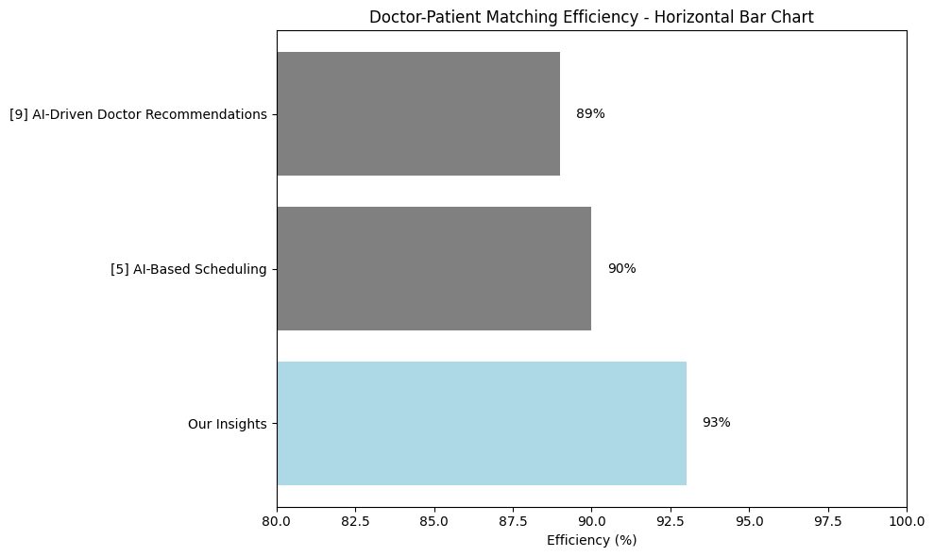
Fig. 4. Doctor-Patient Matching Efficiency

Conclusion
This research is a novel presentation of the HMS that makes use of AI and blockchain to enhance health workflow. It improves upon operational efficiency, data security, and patient services using automated scheduling, prescription management, and billing. AI boosts patient satisfaction and resource use, and blockchain ensures data integrity and privacy. This study promotes sustainability through reduced use of paper in hospitals and smooth running of operations with the help of predictive analytics.
The core focus for this research work, hence, is the development of AI and blockchain technology-based integration for hospital management systems' transformation. Therefore, the strategic challenges to deliver healthcare by a designed HMS will enhance modern prospects to scale, be secure and efficient, thereby necessitating an intelligent approach toward a patient-centered manner for health-care management.

References
- A. Sharma and R. K. Gupta, “Barriers to Adoption of Hospital Management Systems: A Study of Punjab Healthcare Industry,” International Journal of Technology and Business Management, vol. 10, no. 1, pp. 15-22, 2016.
- S. Singh and P. Verma, “Advanced Hospital Management System,” in Proceedings of the International Conference on Advances in Computing and Communication Technologies, 2022, pp. 200-207.
- J. Patel and R. Sharma, “Online Hospital Management System,” International Journal of Computer Applications, vol. 175, no. 7, pp. 25-30, 2022.
- M. Kumar, S. Prasad, and A. Roy, “Blockchain Integration for Hospital Information System Management,” Journal of Digital Health Technologies, vol. 6, no. 4, pp. 145-152, 2022.
- T. Wang, “AI-Based Scheduling System for Hospital Management,” in Proceedings of the AI in Healthcare Symposium, 2021, pp. 101-108.
- P. Das and N. Kapoor, “Virtual Waiting Room for Improved Patient Experience,” Journal of Healthcare Innovation and Management, vol. 4, no. 3, pp. 85-91, 2020.
- R. Kumar, S. Rajan, and P. Gupta, “Interlinked Hospital Management System,” International Conference on Healthcare Informatics, 2018, pp. 213-220.
- L. Wei, M. Zhang, and H. Li, “Blockchain for Secure Prescription and Medical Records in Hospital Management Systems,” Journal of Information Security and Applications, vol. 58, no. 2, pp. 1-9, 2022.
- V. Shukla, “AI-Driven Doctor Recommendation System Based on Specialization,” Proceedings of the IEEE Conference on Artificial Intelligence in Medicine, 2022, pp. 78-85.
- K. Iyer, “Automated Billing in Healthcare Systems Using AI,” Journal of Intelligent Systems in Medicine, vol. 3, no. 5, pp. 142-149, 2021.
- A. Fernandez and B. Cohen, “Feedback-Based AI Systems for Continuous Learning,” IEEE Transactions on Neural Networks and Learning Systems, vol. 32, no. 10, pp. 1-10, 2021.

